**Analog Optocoupler**

Since we need full isolation between input and output sides, we need to send the output voltage information to input side, where controller is placed, in an isolated way. We used TLP291 analog optocoupler to transfer voltage level to controller. Circuit schematic of the optocoupler is given in Figure A1. Depending on the output voltage level, optocoupler LED sends light to photoreceiver and voltage is read by controller. Supply voltage of the photoreceiver is taken from 15V output of buck converter IC. Load resistance 1kΩ will be divided according to error amplifier design.

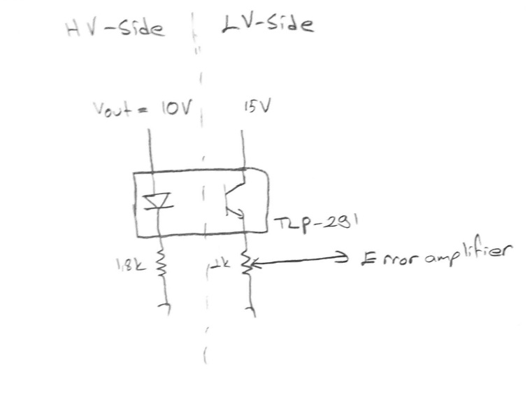

**Figure A1. Circuit schematic of analog optocoupler (will be replaced by circuit drawing)**

**Gate Driver**

Analog controller cannot provide enough power to turn MOSFET on. We used ZXGD3009DY as a low side gate driver. It provides up to 40V 1A output current which is enough for our MOSFET application. Supply voltage is taken from output of the buck converter. Controller PWM output signal is connected to input of the driver and output is connected to gate of the MOSFET. Connections of the driver is given in Figure A2.

**Figure A2. Circuit schematic of gate driver (will be placed)**

**Buck Converter**

Maximum VGS voltage of the MOSFET is 20V. To obtain gate driving voltage and to supply analog controller and optocoupler, we used D36V6F15 DC/DC voltage converter. Selected buck converter can convert 15.2-50V to 15V. Input of the converter is connected to main input of the circuit and between 24-48V. Output of the buck converter is fixed and 15V. Circuit schematic of the converter is given in Figure A3.

**Figure A3. Circuit schematic of buck converter (will be placed)**